Experiment Details

|  |  |
| --- | --- |
| Department Name | Basic Science and Humanities |
| Class | FY B.Tech |
| Semester | 1 st |
| Subject Name | Basic Mechanical Lab |
| Experiment No. | 01 |
| Experiment Name | Study of steam thermal power plant |

Version History

|  |  |  |  |  |
| --- | --- | --- | --- | --- |
| Sr. No. | Version Number | Created By | Approved By | Date |
| 1 | v1.0 | Sonali Yeranale | MRS. Pooja Patil | 06/10/2020 |
|  |  |  |  |  |

AIM:-

To Study of steam thermal power plant

THEORY:-

Steam power plant, also known as thermal power plant, is using steam as working fluid. Steam is produced in a boiler using coal as fuel and is used to drive the prime mover, namely, the steam turbine. In the steam turbine, heat energy is converted into mechanical energy which is used for generating electric power. Generator is an electromagnetic device which makes the power available in the form of electrical energy.

Layout of Steam Thermal Power Plant:

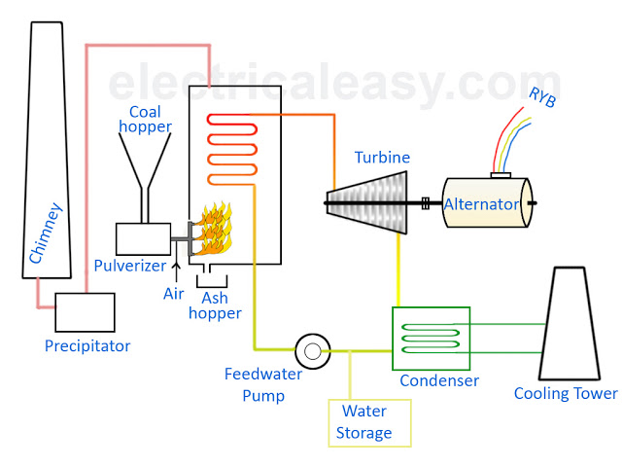

Fig:- Layout of steam thermal power plant

The layout of the steam power plant is shown in figure below. It consists of four main circuits. These are: Coal and ash circuit, Air and flue gas circuit, Water and steam circuit and cooling water circuit

**Coal and ash circuit**: Coal from the storage yard is transferred to the boiler furnace by means of coal handling equipment like belt conveyor, bucket elevator, etc., ash resulting from the combustion of coal in the boiler furnace collects at the back of the boiler and is removed to the ash storage yard through the ash handling equipment.

**Ash disposal**: The Indian coal contains 30% to 40% ash. A power plant of 100MW 20 to 25 tonnes of hot ash per hour. Hence sufficient space near the power plant is essential to dispose such large quantities of ash.

**Air and flue gas circuit**: Air is taken from the atmosphere to the air preheater. Air is heated in the air preheater by the heat of flue gas which is passing to the chimney. The hot air is supplied to the furnace of the boiler. The flue gases after combustion in the furnace pass around the boiler tubes. The flue gases then passes through a dust collector, economizer and pre-heater before being exhausted to the atmosphere through the chimney. By this method the heat of the flue gases which would have been wasted otherwise is used effectively. Thus the overall efficiency of the plant is improved.

**Air pollution**: The pollution of the surrounding atmosphere is caused by the emission of objectable gases and dust through the chimney. The air pollution and smoke cause nuisance to people surrounding the planet.

**Feed water and steam circuit**: The steam generated in the boiler passes through super heater and is supplied to the steam turbine. Work is done by the expansion of steam in the turbine and the pressure of steam is reduced. The expanded steam then passes to the condenser, where it is condensed. The condensate leaving the condenser is first heated in a l.p. water heater by using the steam taken from the low pressure extraction point of the turbine. Again steam taken from the high pressure extraction point of the turbine is used for heating the feed water in the H.P water heater. The hot feed water is passing through the economizer, where it is further heated by means of flue gases. The feed water which is sufficiently heated by the feed water heaters and economizer is then fed into the boiler.

**Cooling water circuit**: Abundant quantity of water is required for condensing the steam in the condenser. Water circulating through the condenser may be taken from various sources such as river or lake, provided adequate water supply is available from the river or lake throughout the year. If adequate quantity of water is not available at the plant site, the hot water from the condenser is cooled in the cooling tower or cooling ponds and circulated again.

PRE TEST:-

1. The modern steam turbines are

* Impulse turbines
* Reaction turbines
* Impulse-reaction turbines
* None of the above

Answer: - Impulse-reaction turbines

2. The cooling section in the surface condenser

* Increases the quantity of vapor extracted along with air
* Reduces the quantity of vapor extracted along with air
* Does not affect vapor quantity extracted but reduces pump capacity of air extraction pump
* None of the above

Answer: - Reduces the quantity of vapor extracted along with air

3. Parson’s turbine is

* Pressure compounded steam turbine
* Simple single wheel, impulse steam turbine
* Simple single wheel reaction steam turbine
* Multi wheel reaction steam turbine

Answer: - Multi wheel reaction steam turbine

4. Reheat cycle in steam power plant is used to

* Utilize heat of flue gases
* Increase thermal efficiency
* Improve condenser performance
* Reduce loss of heat

Answer: - Increase thermal efficiency

5. For the safety of a steam boiler the numbers of safety valves fitted are

* Four
* Three
* Two
* One

Answer: - two

PROCEDURE:-

12

The pulverized coal is fed into the boiler where the pulverized coal is burnt into the furnace.

⎫ Due to heat from the furnace, the water present in the boiler drum changes to the high

1. The pulverized coal is fed into the boiler where the pulverized coal is burnt into the furnace.

Due to heat from the furnace, the water present in the boiler drum changes to the high

2. Due to heat from the furnace, the water present in the boiler drum changes to the high pressure steam.

3. From the boiler this high pressure steam is passed to the super heater where it is again heated up to its dryness.

4. After that this super-heated steam strikes the turbine blades with a high speed and the turbine blades starts rotating to at high speed. Here the stored potential energy of the steam is gets converted into mechanical energy

5. A generator is coupled with the turbine rotor. As the turbine rotates, the generator also rotate with same speed and mechanical energy of the turbine gets converted into electrical energy.

Steam after hitting the turbines blades lost its most of the energy and leaves the turbine

6. Steam after hitting the turbines blades lost its most of the energy and leaves the turbine

With low pressure steam.

⎫ This low pressure steam enters into the condenser. Cold water circulates in the condenser

⎫ This low pressure steam enters into the condenser. Cold water circulates in the condenser

⎫ This low pressure steam enters into the condenser. Cold water circulates in the condenser

⎫ This low pressure steam enters into the condenser. Cold water circulates in the condenser

⎫ This low pressure steam enters into the condenser. Cold water circulates in the condenser

⎫ This low pressure steam enters into the condenser. Cold water circulates in the condenser

⎫ This low pressure steam enters into the condenser. Cold water circulates in the condenser

7. This low pressure steam enters into the condenser. Cold water circulates in the condenser from the cooling tower. Here the low pressure wet steam is converted into water.

8. After that condensed water with the feed water passed to the economizer where it gets heated up by the economizer. And finally the feed water enters into the boiler by a feed water pump to repeat the cycle.

9. The burnt flue gases from the furnace passes through the super heater, economizer and air pre-heater. This heat of the flue gases is used to heat the steam in the super heater to its dryness, to heat feed water in the economizer before entering into the boiler and to heat air form the atmosphere in the air pre-heater before it enters into the furnace.

10. The ash from the furnace is transported to ash handling plant and finally to the ash storage.

After that this super-heated steam strikes the turbine blades with a high speed and the

POST TEST:

1. The pressure at the furnace is minimum in case of
   * Forced draught system
   * Induced draught system
   * Balanced draught system
   * Natural draught system

Answer: - Balanced draught system

1. In a boiler installation the natural draught is produced
   * Due to the fact that furnace gases being light go through the chimney giving place to cold air from outside to rush in
   * Due to the fact that pressure at the grate due to cold column is higher than the pressure at the chimney base due to hot column
   * Due to the fact that at the chimney top the pressure is more than its environmental pressure
   * All of the above

Answer: - Due to the fact that pressure at the grate due to cold column is higher than the pressure at the chimney base due to hot column

3. In a regenerative feed heating cycle, the greatest economy is affected

* + When steam is extracted from only one suitable point of steam turbine
  + When steam is extracted from several places in different stages of steam turbine
  + When steam is extracted only from the last stage of steam turbine
  + When steam is extracted only from the first stage of steam turbine

Answer: - When steam is extracted from several places in different stages of steam turbine

4. Method which is commonly applied for unloading the coal for small power plant is

* Lift trucks
* Coal accelerators
* Tower cranes
* Belt conveyor

Answer: - Coal accelerators

5. Blowing down of boiler water is the process

* To reduce the boiler pressure
* To increase the steam temperature
* To control the solid concentration in the boiler water by removing some of the concentrated saline water
* None of the above

Answer: - To control the solid concentration in the boiler water by removing some of the concentrated saline water

REFERENCES:

Basic Mechanical by Sadhu Singh, Elements of Mechanical Engineering.